Netaji Subhash University of Technology



OPERATING SYSTEM LAB FILE

SUBMITTED BY-

2020UEA6576

VANSH GUPTA

SUBMITTED TO-

Ms. SAUMIYA RANI

**EXPERIMENT**

**AIM:** To implement bankers algorithm

CODE:

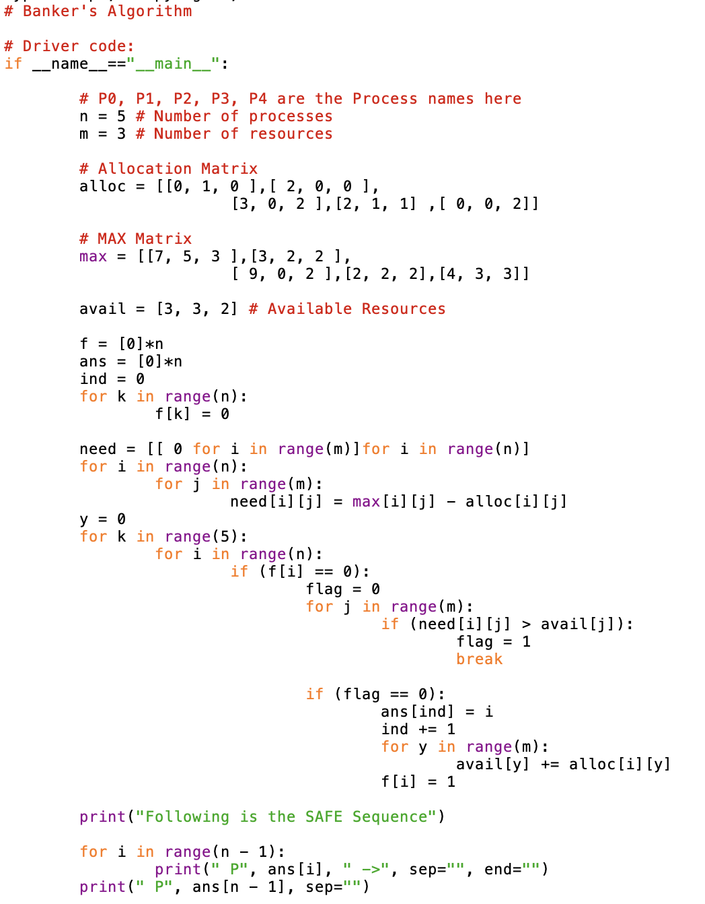

OUTPUT:

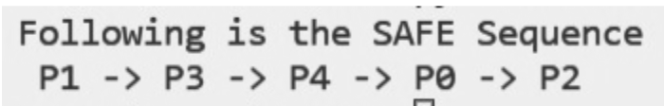

**EXPERIMENT**

**AIM:** To implement FIRST COME FIRST SERVE

CODE:

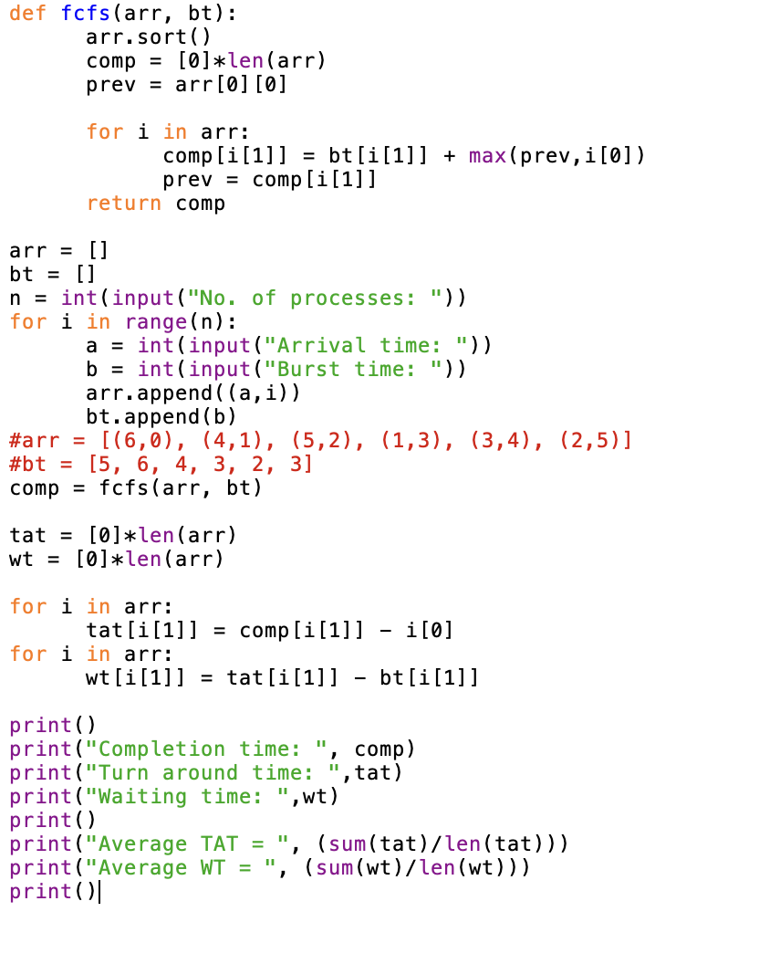

OUTPUT:

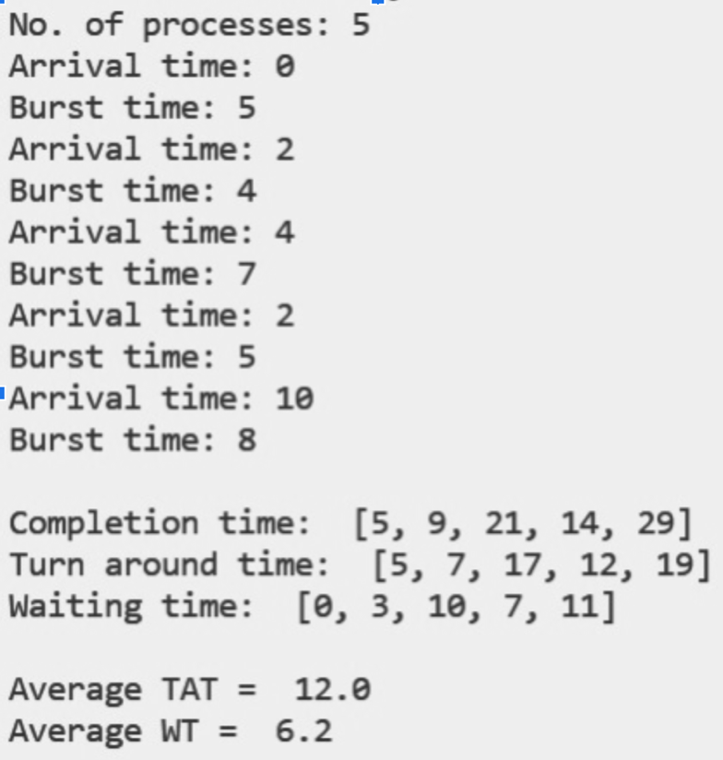

**EXPERIMENT**

**AIM:** To implement ROUND ROBIN

CODE:

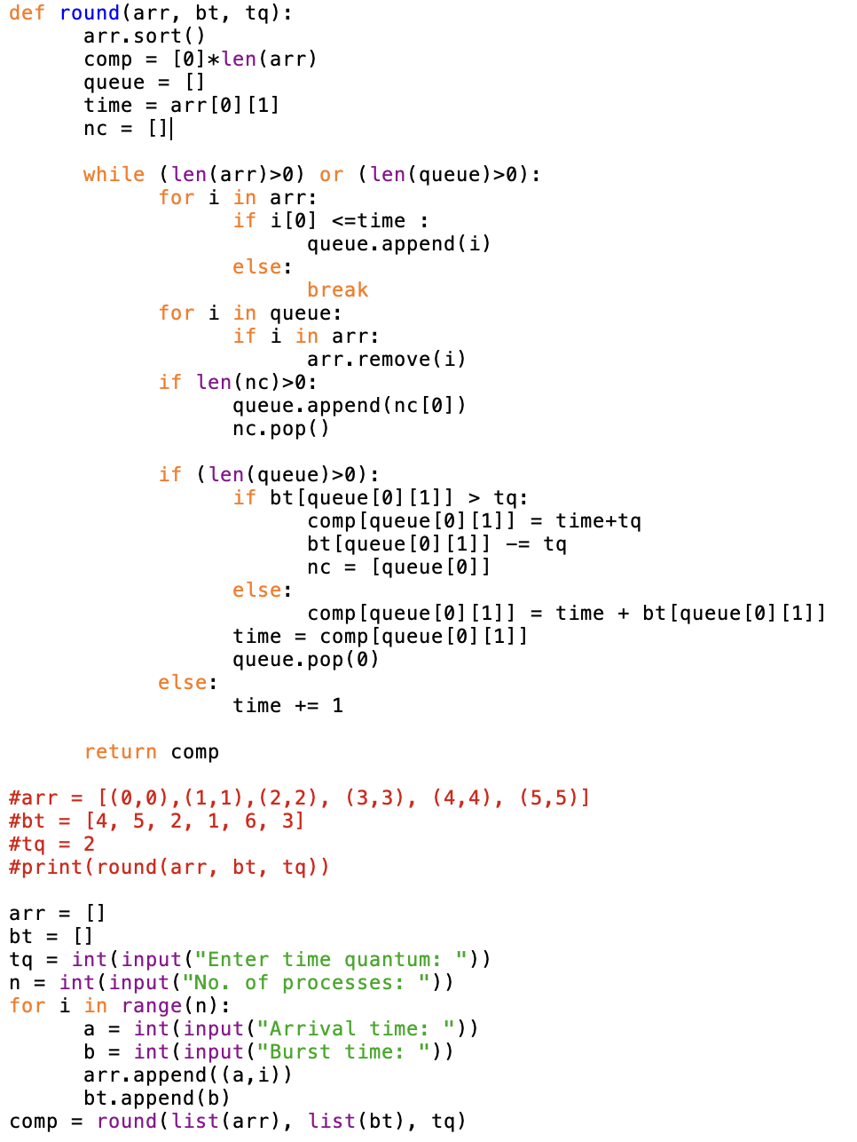

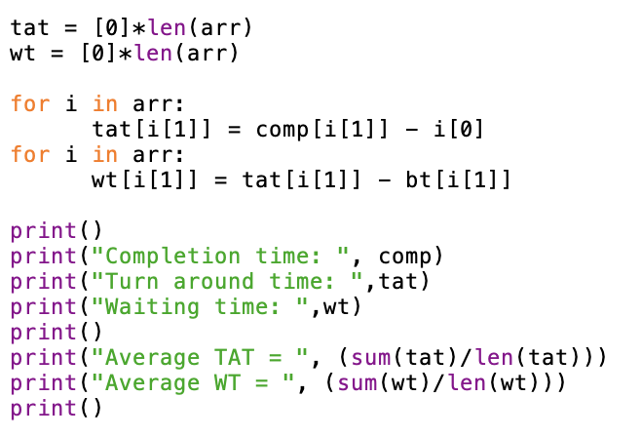

OUTPUT:

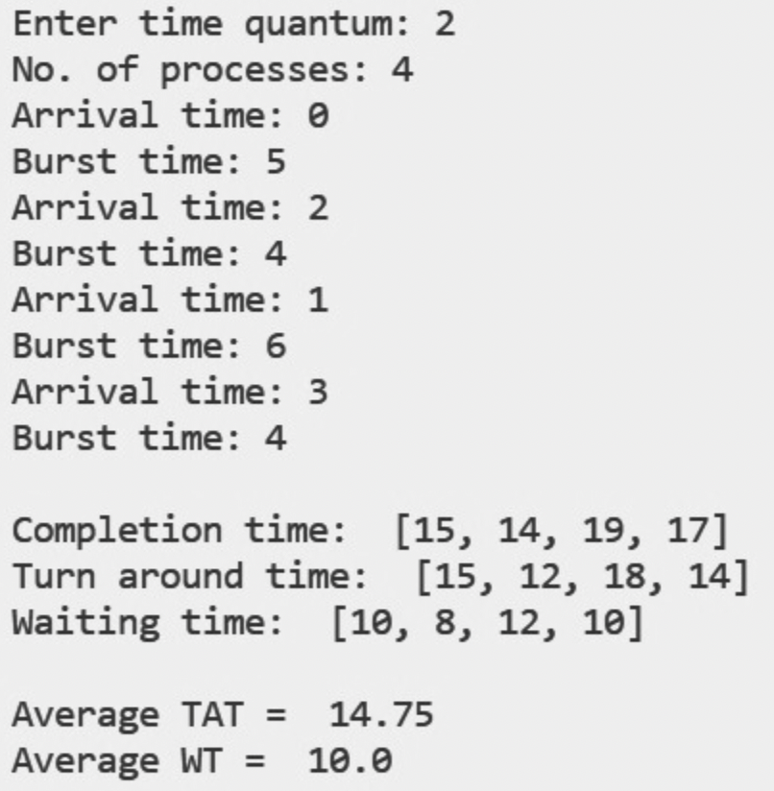

**EXPERIMENT**

**AIM:** To implement SHORTEST JOB FIRST

CODE:

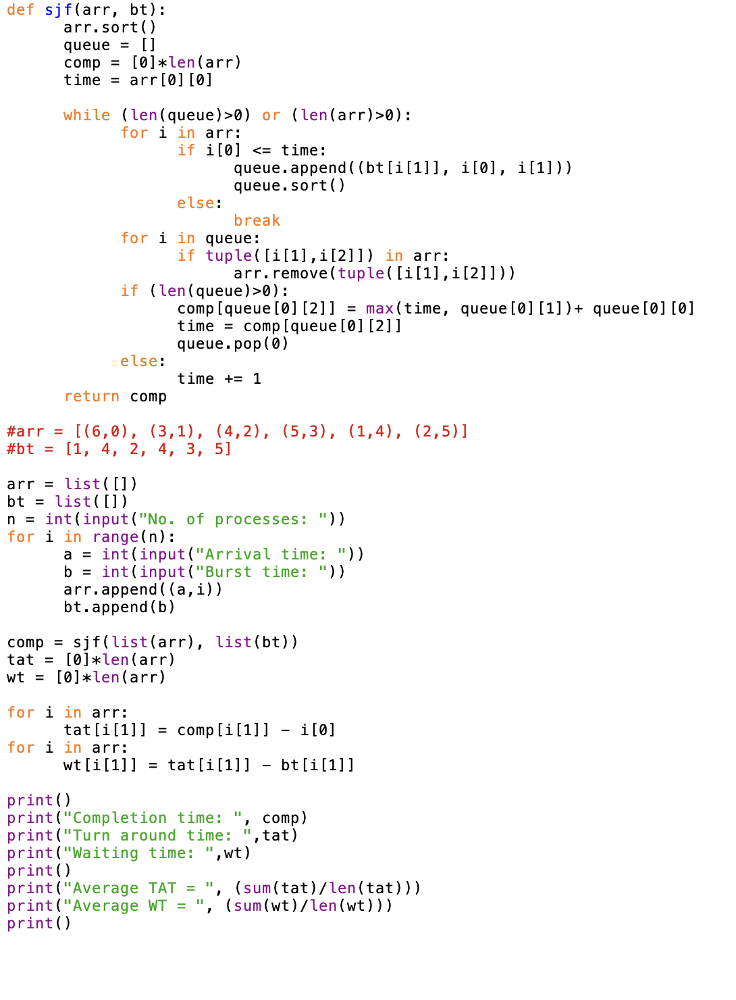

OUTPUT:

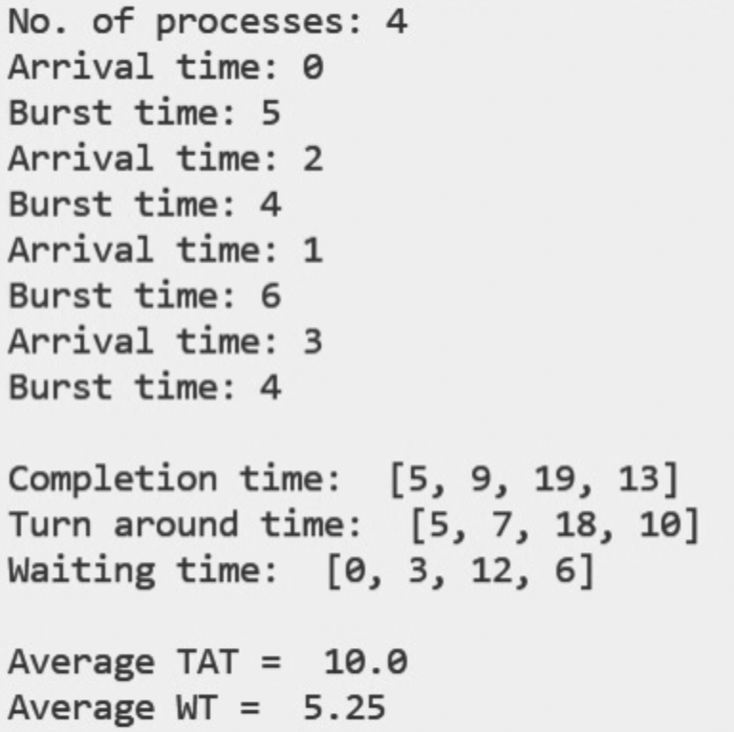

**EXPERIMENT**

**AIM:** To implement FIRST REMAINING TIME FIRST

CODE:

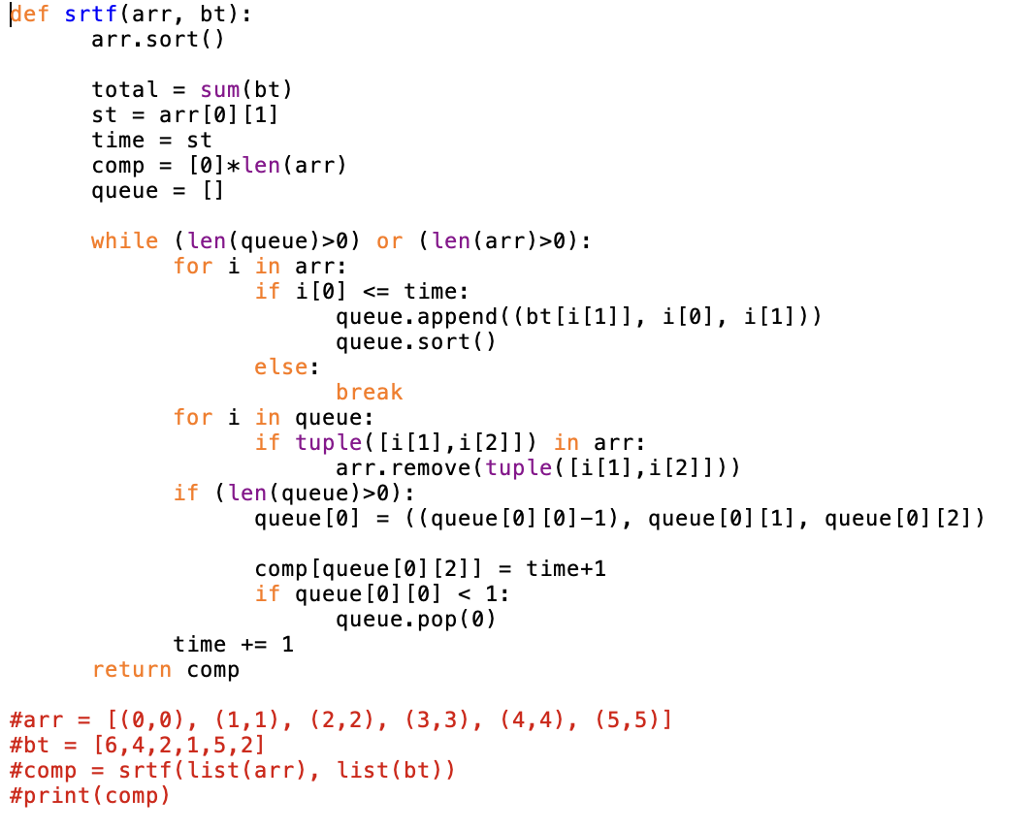

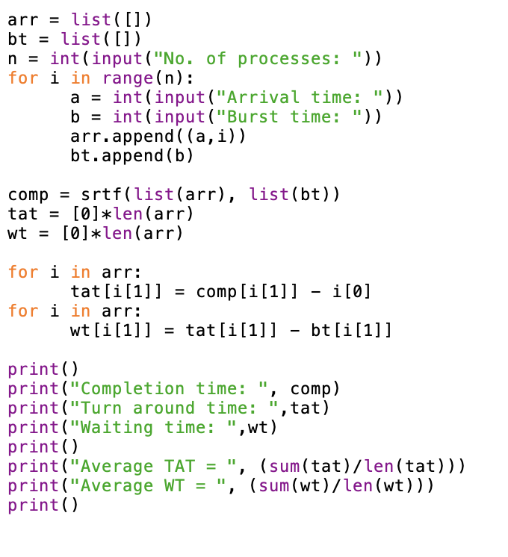

OUTPUT:

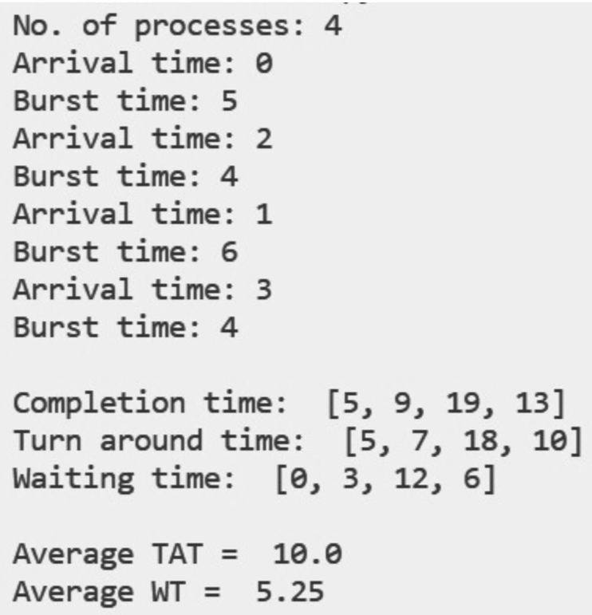

**EXPERIMENT**

**AIM:** To implement PRIORITY BASED SCHEDULING (non premitive)

CODE:

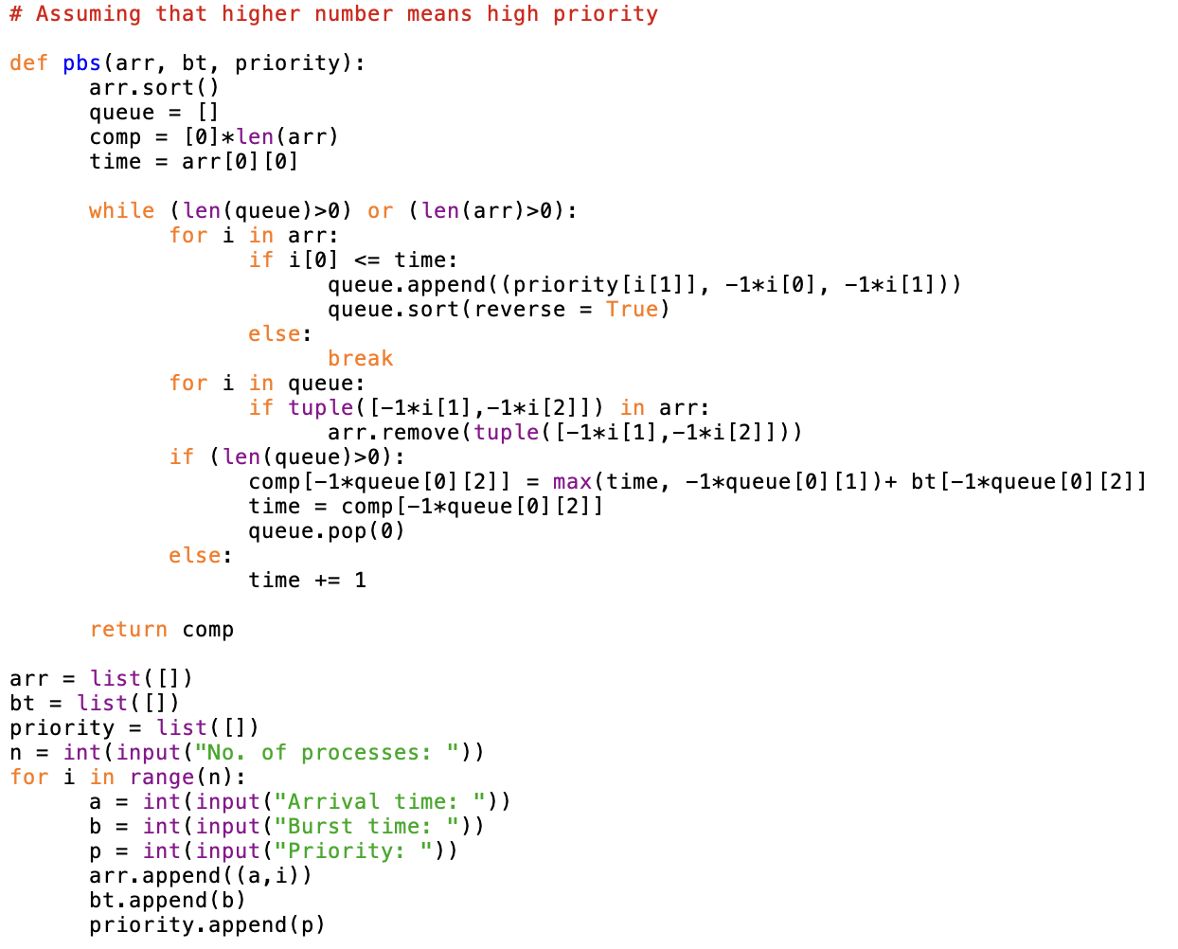

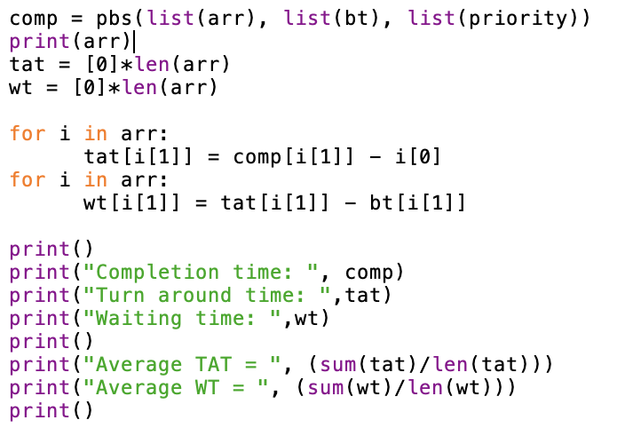

OUTPUT:

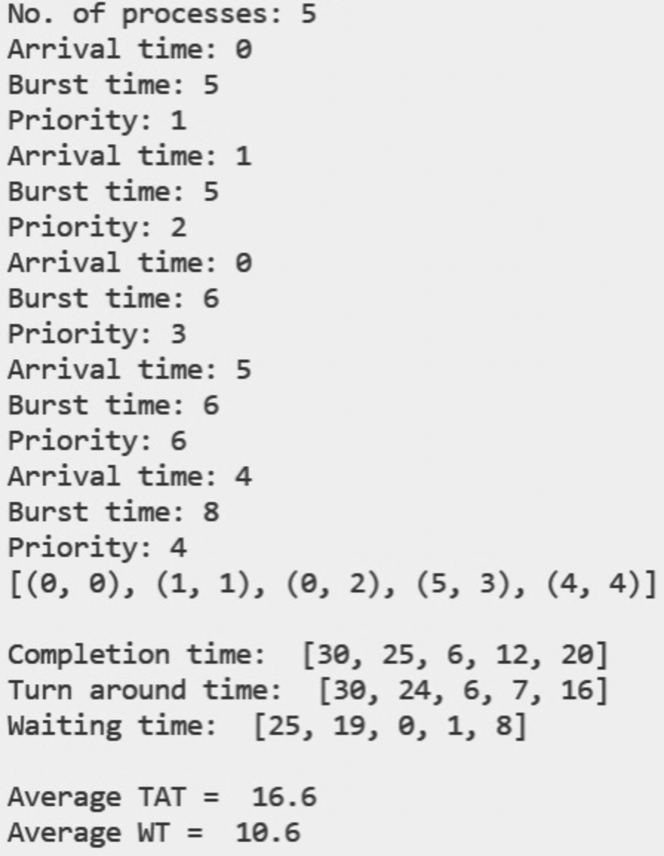

**EXPERIMENT**

**AIM:** To implement PRIORITY BASED SCHEDULING (premitive)

CODE:

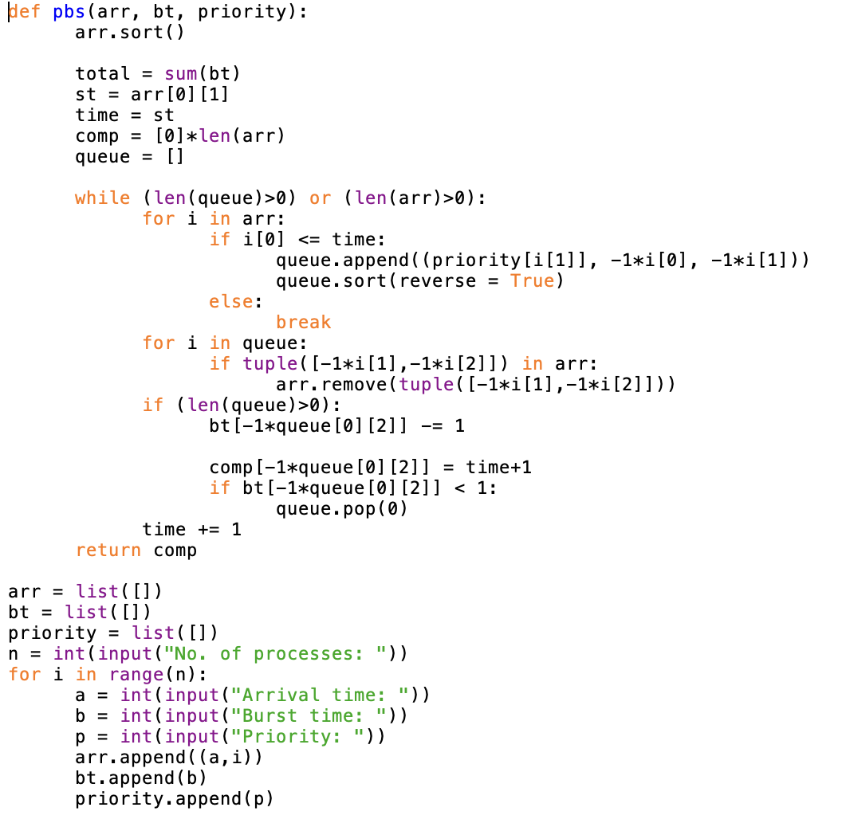

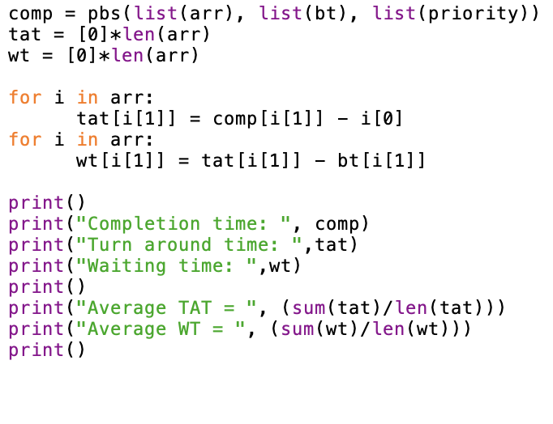

OUTPUT:

